**Topics: Confidence Intervals**

1. For each of the following statements, indicate whether it is True/False. If false, explain why.
2. The sample size of the survey should at least be a fixed percentage of the population size in order to produce representative results.

**Ans:-** False: The result depend on the size(n). the sample size should have at least 30 observation.

1. The sampling frame is a list of every item that appears in a survey sample, including those that did not respond to questions.

**Answer:** - False.

The sampling frame is a list of all the items in the population from which the sample is drawn. It is not a list of items in the sample itself, whether they responded to the survey or not.

1. Larger surveys convey a more accurate impression of the population than smaller surveys.

Ans:- True: The larger conveys a more accurate impression of the population as larger surveys involve large sample size which reduces the chances of error

1. *PC Magazine* asked all of its readers to participate in a survey of their satisfaction with different brands of electronics. In the 2004 survey, which was included in an issue of the magazine that year, more than 9000 readers rated the products on a scale from 1 to 10. The magazine reported that the average rating assigned by 225 readers to a Kodak compact digital camera was 7.5. For this product, identify the following:
2. The population :-

Readers of the PC Magazine= 9000

1. The parameter of interest:-

population size, average, sample size and ratings for camera (7.5 )

1. The sampling frame

each and every reader that responded by rating the products

1. The sample size

225

1. The sampling design

Voluntary Response

1. Any potential sources of bias or other problems with the survey or sample
2. For each of the following statements, indicate whether it is True/False. If false, explain why.
3. If the 95% confidence interval for the average purchase of customers at a department store is $50 to $110, then $100 is a plausible value for the population mean at this level of confidence.

TRUE

1. If the 95% confidence interval for the number of moviegoers who purchase concessions is 30% to 45%, this means that fewer than half of all moviegoers purchase concessions.

False. We have evidence in that direction but we cannot confirm 100% based on this data. We have to consider the values out of this range(i.e. more than 95% confidance interval)

1. The 95% Confidence-Interval for *μ* only applies if the sample data are nearly normally distributed.

False. The 95% confidence interval for μ (population mean) applies as long as the sample size is sufficiently large, regardless of the distribution of the sample data, due to the central limit theorem. However, if the sample size is small and the population distribution is non-normal, the confidence interval may not be accurate.

1. What are the chances that ?
2. ¼
3. ½
4. ¾
5. 1

Ans:-B.This is pure assumption. There is a 50% chance that the sample mean(x̄)

greater than the population mean(μ).

1. In January 2005, a company that monitors Internet traffic (WebSideStory) reported that its sampling revealed that the Mozilla Firefox browser launched in 2004 had grabbed a 4.6% share of the market.
2. If the sample were based on 2,000 users, could Microsoft conclude that Mozilla has a less than 5% share of the market?

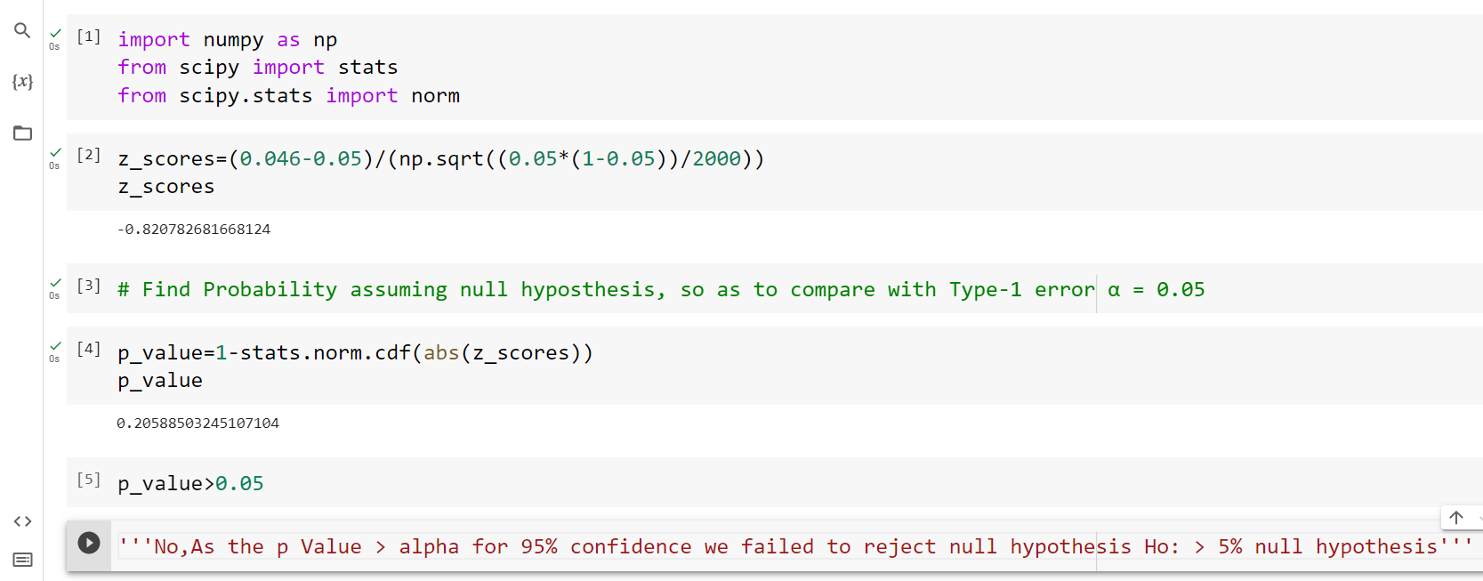

1. WebSideStory claims that its sample includes all the daily Internet users. If that’s the case, then can Microsoft conclude that Mozilla has a less than 5% share of the market?

Yes

1. **A book publisher monitors the size of shipments of its textbooks to university bookstores. For a sample of texts used at various schools, the 95% confidence interval for the size of the shipment was 250 ± 45 books. Which, if any, of the following interpretations of this interval are correct?**
2. **All shipments are between 205 and 295 books.**
3. Ans: - This interpretation is not correct. The confidence interval provides an estimate of the range in which the true population mean is likely to fall, not the range for individual shipments.
4. **95% of shipments are between 205 and 295 books**.

Ans:- This interpretation is not correct. The confidence interval provides information about the likely range for the population mean, not for individual shipments. It does not make a statement about a specific percentage of shipments falling within this range.

1. **The procedure that produced this interval generates ranges that hold the population mean for 95% of samples.**

**Ans:-**

This interpretation is correct. The 95% confidence interval implies that if we were to repeat the sampling process many times and construct a confidence interval for each sample, approximately 95% of these intervals would contain the true population mean.

1. **If we get another sample, then we can be 95% sure that the mean of this second sample is between 205 and 295.**

**Ans:-**

This interpretation is not correct. The confidence interval is specifically about the population mean, not the mean of a second sample. It is about the range that likely contains the true population mean, not the range for individual sample means

1. We can be 95% confident that the range 160 to 340 holds the population mean.

**Ans-** This interpretation is not correct. The confidence interval provided in the question is 250 ± 45 books, which corresponds to the range (205, 295). It does not include the range 160 to 340**.**

1. Which is shorter: a 95% *z*-interval or a 95% *t*-interval for *μ* if we know that σ =s?
2. The z-interval is shorter
3. The t-interval is shorter
4. Both are equal
5. We cannot say

Ans: A

If we know that σ = s, we can use the z-distribution instead of the t-distribution to calculate confidence intervals, since the sample size needed to assume normality is lower. The z-distribution has thinner tails than the t-distribution, which means that it has less probability in the tails and more probability in the center compared to the t-distribution. As a result, the z-interval will be narrower (shorter) than the t-interval.

So the answer is:

**The z-interval is shorter.**

Questions 8 and 9 are based on the following: To prepare a report on the economy, analysts need to estimate the percentage of businesses that plan to hire additional employees in the next 60 days.

1. How many randomly selected employers (minimum number) must we contact in order to guarantee a margin of error of no more than 4% (at 95% confidence)?
2. 600
3. 400
4. 550
5. 1000

Ans: A

Z= 95% confidence level, the Z-score is 1.96.

P=0.5

q = 1-0.5= 0.5

E= 0.04(4%)

n = (Z^2 * p * q) / E^2

n = (1.96^2 * 0.5 * 0.5) / 0.04^2

n = 0.9604 / 0.0016

n = 600.25

1. Suppose we want the above margin of error to be based on a 98% confidence level. What sample size (minimum) must we now use?
2. 1000
3. 757
4. 848
5. 543

Ans:- C

To calculate the minimum sample size needed for a given margin of error at a specific confidence level, we use the formula:

n = (Z^2 * p * q) / E^2

Z= 2.326 for a 98% confidence level

P= 0.5

q= 1-0.5

E=0.04

n = (2.326^2 * 0.5 * 0.5) / 0.02^2

n = 1.3525/0.0016

n= 845.35